Write the sentences. Use There is or There are.
Napíšte vety. Použite THERE IS alebo THERE ARE. Deti, pracovný list si vytlačte v tlačiarni...ak takú možnosť nemáte, vystačíte si aj písaním do vašich zošitov z ANJ.

............................................................................................................................
.......................................................................................................................................

...........................................................................................................................................

.................................................................................................................................................

........................................................................................................................

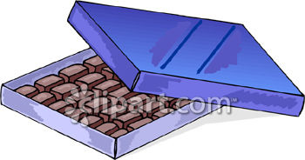....................................................................................................................
Draw: (Nakresli jednu vec a použi slovné spojenie THERE IS... A do druhého rámčeka viac vecí a použi slovné spojenie THERE ARE...) . GOOD LUCK!!!!

There is ....................................................................................................................

There are ....................................................................................................................

