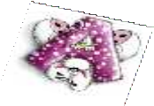
Prelož:

- The lamp is on the blue table.

- I have got a computer.

- I have not got a train.

- There is a cat under the chair.

- This is my sister Anna.
Prelož:

  - The teddy is on the green chair.

  - I have not got a computer.

  - I have got a ball.

  - There is a dog on the sofa.

  - This is my brother Peter.

